Permutation program ideas

## **perm-yoo-TAY-shun**

a way, especially one of several possible variations, in which a set or number of things can be ordered or arranged.

* Find all possible anagrams of a word. (e.g. for CAT, there is CTA, TAC, TCA, ACT, and ATC.)
* Find all word anagrams that appear in a dictionary (e.g. for CAT, there is CTA[1], TAC[2], and ACT.
* Find all word anagrams that meet a specific criterium (e.g. for all anagrams of CAT that start with T, there is TAC and TCA)
* Find all possible combinations for a code (e.g. for a 2-digit combination lock, there is 01, 02, 03, 04, 05, 06, 07, 08, 09, 10, etc.)
* Find a way to make the program work for 4-letter words
* Find

1. 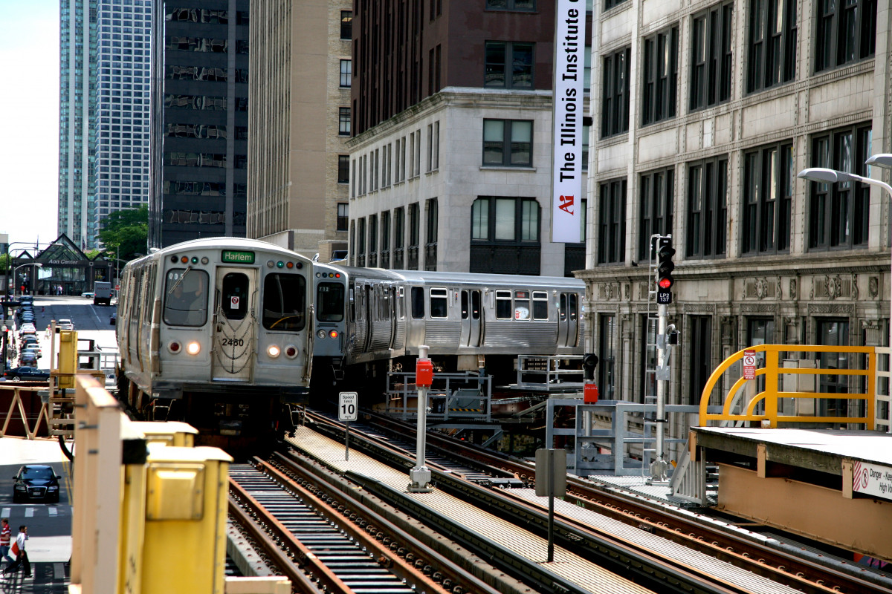
2. Tic ___ toe